**Recommended online notice board**  
**Requirements Specifications**

**Author:** Mehedi hasan

**Revision:** 29/04/2018

**Abstract:**

From the question part

Yes we need online notice board for our department

1. the all kind of information are added in that notice board

2. firstly of all we need to create a website for online publications .Also we can use facebook page to create a online notice board .

3. We need to appoint a person to gather the all activities that happen in the certain time in our department .

4. We can also add our regular routine of class that happened today or the regular week

5. we can also add the result of our semester final that happen before

6. we can add the office information for exam registration

7. we can add information just like the exam fees ;the lab fees; add the other fees also be added

8. we can also add the current student information that is badly needed for our department

9. we can also add the e-books and the holiday schedules to know about our vacations

10. we can add the Teacher information that is help to make sure the proper lab report for our department

11. we can also add the room no; lab –no and the current room information

**Prototyping**

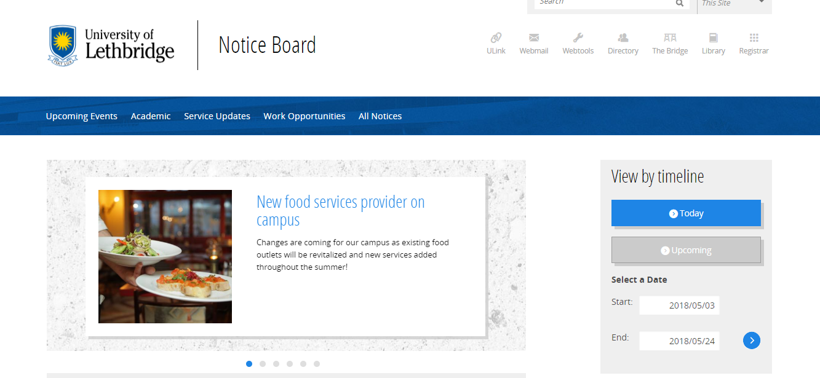

Just like it